Hive Analysis:

Datbases:

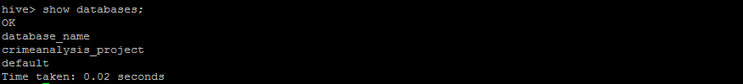

Tables:

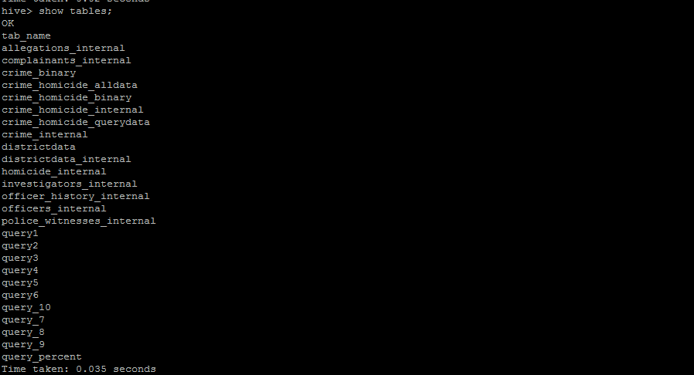

Files in Metastore_Db:

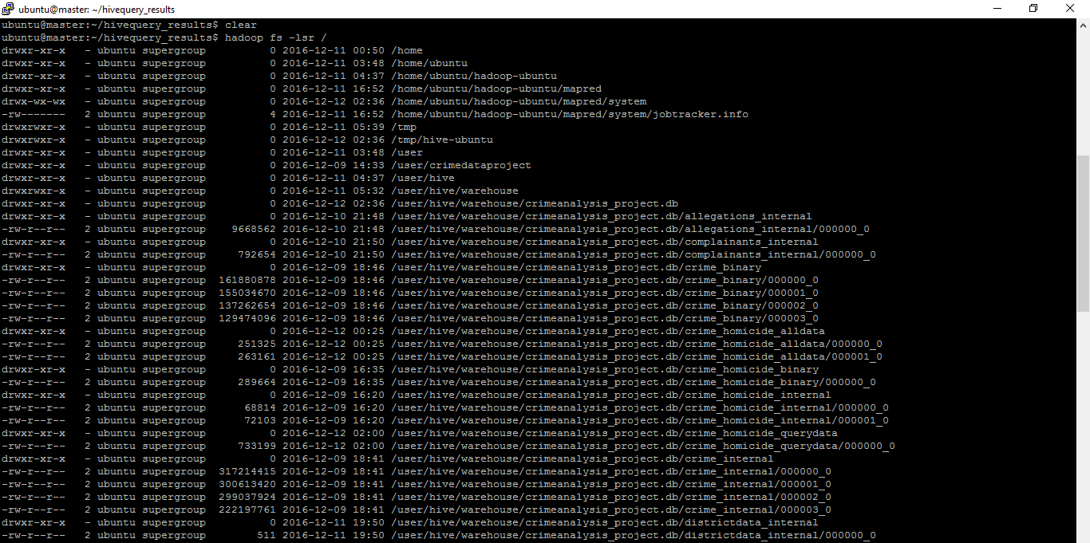

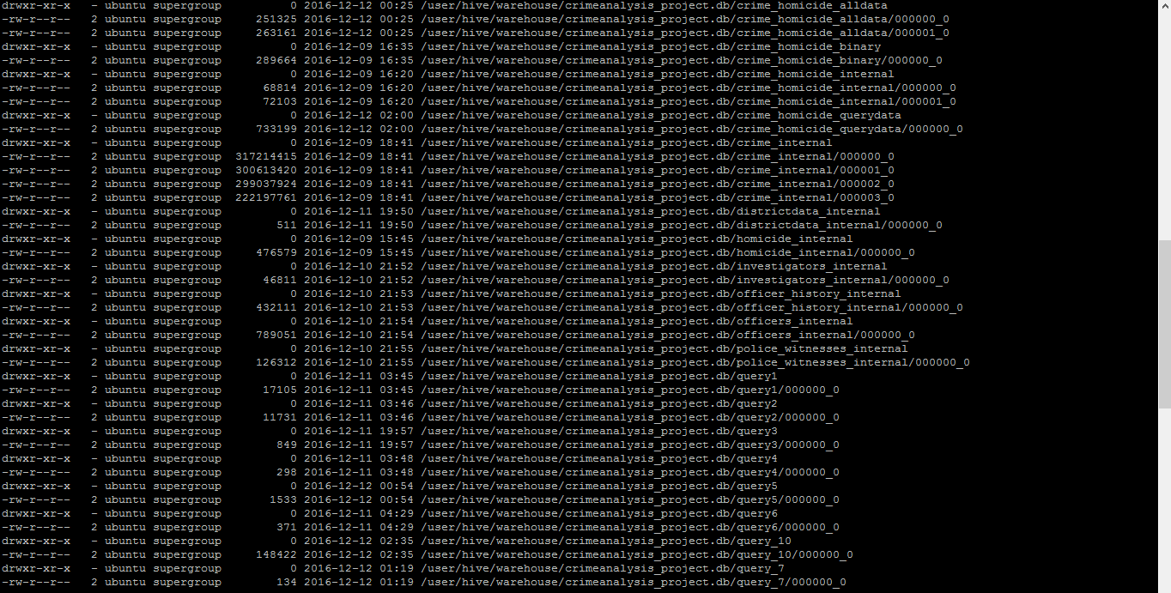

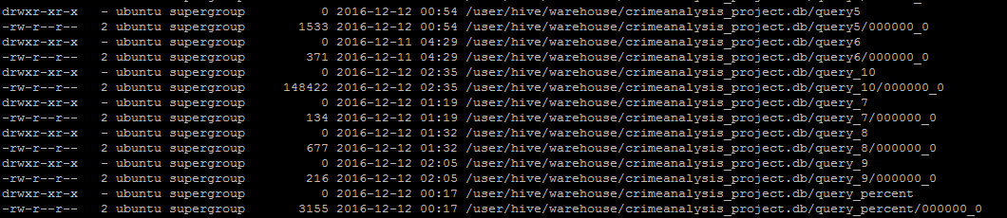

**Query1: Crimes by Crime Category**

create table query1 as

select Primary_Type,Description,count(*) as CrimeCount

from crime_internal

group by Primary_Type,Description order by Primary_Type,Description;

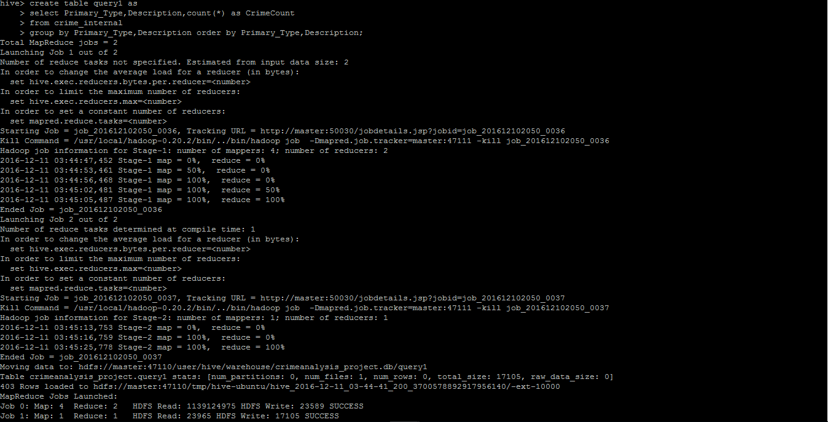

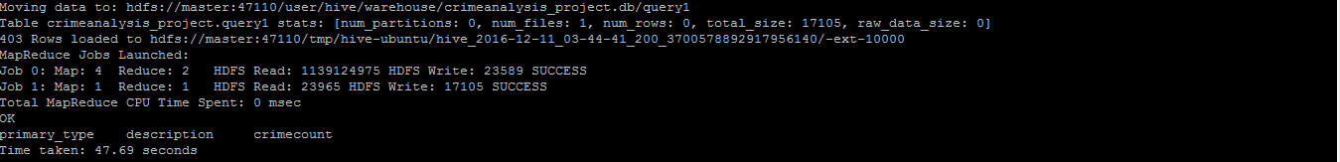

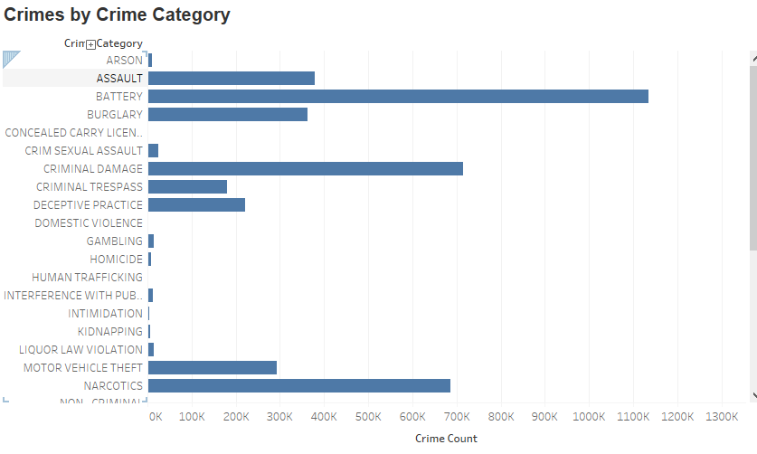

***Conclusion:*** *This analysis for the crimes based on crime category and sub category.This will be useful to Police Department to analyse what type of crimes are more occurring and they can take appropriate measures to reduce.*

**Query2: Year wise crime data**

create table query2 as

select year_crime,primary_type,count(*) as CrimeCount

from crime_internal

group by year_crime,primary_type

order by year_crime,primary_type;

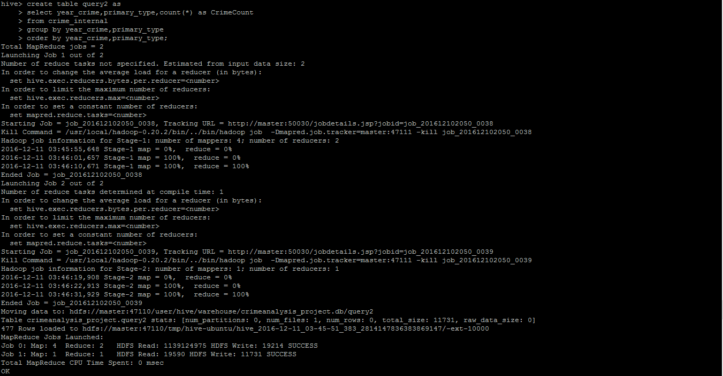

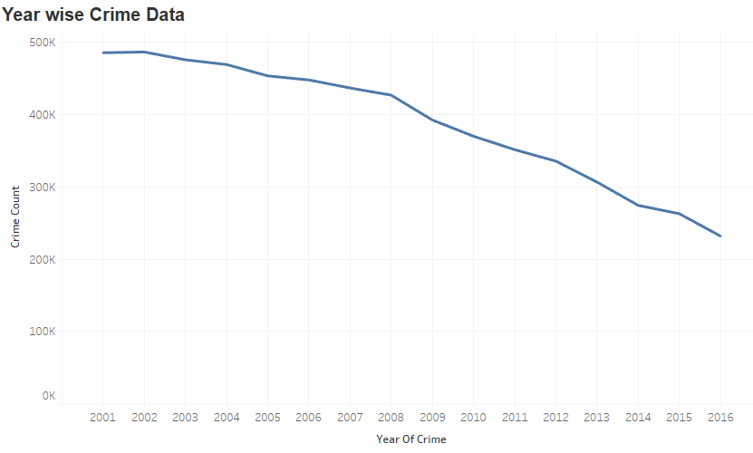

***Conclusion:*** *This analysis for the crimes based on crime category and sub category on a yearly basis.This will be useful to Police Department to analyse what type of crimes are more occurring in each year and they can compare the occurrences of a particular crime in different years and they can take appropriate measures to reduce.*

**Query3: Districts with the crime category it is most vulnerable to**

create table query3 as

select d.district,e.district_name,e.zipcode,d.primary_type,d.count_crimetype_district from

(select c.district,b.primary_type,c.count_crimetype_district from

(select district,max(CrimeCount) count_crimetype_district

from

(select district,primary_type,count(*) as CrimeCount

from crime_internal group by district,primary_type)a group by district)c

join

(select district,primary_type,count(*) as CrimeCount

from crime_internal

group by district,primary_type)b

on b.district=c.district and c.count_crimetype_district=b.CrimeCount) d

join districtdata_internal e

on d.district=e.district

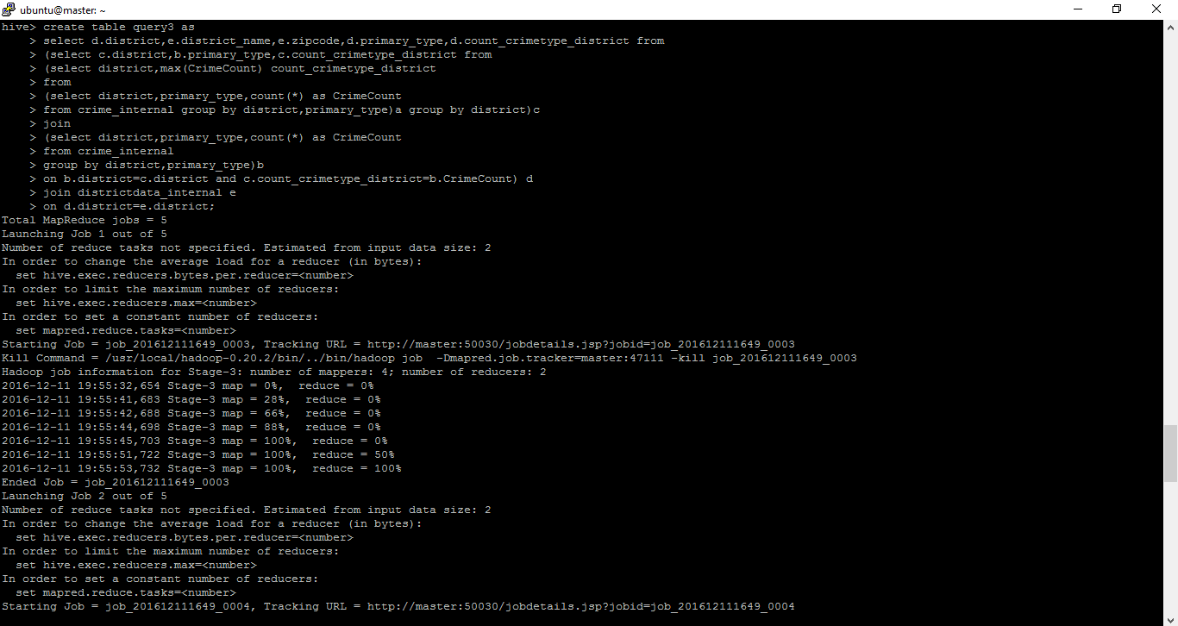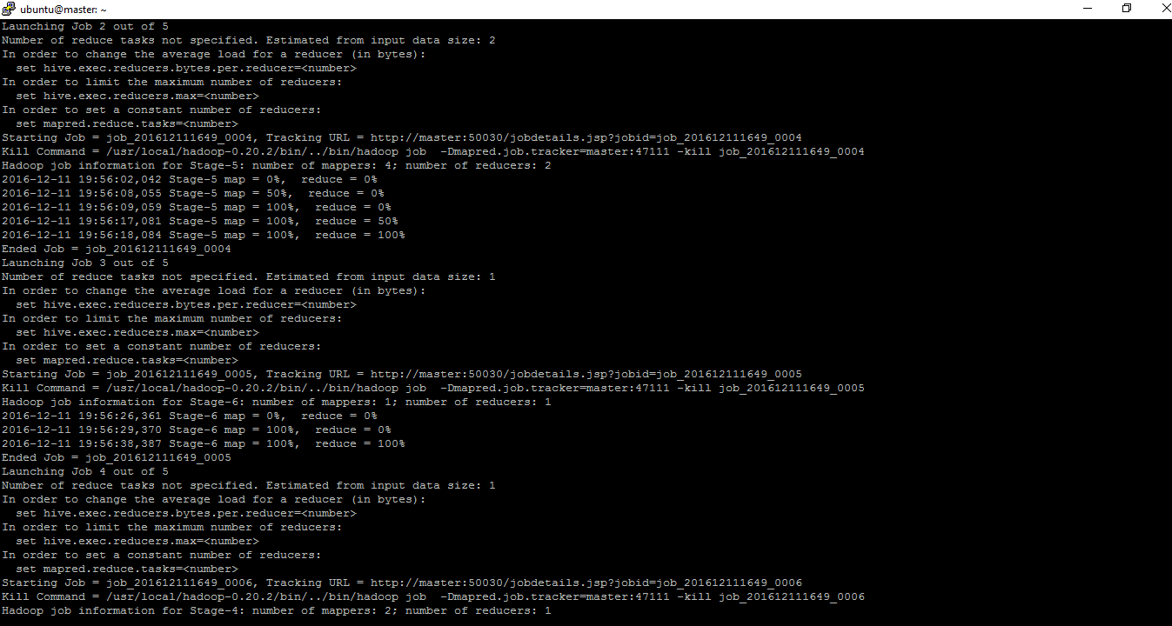

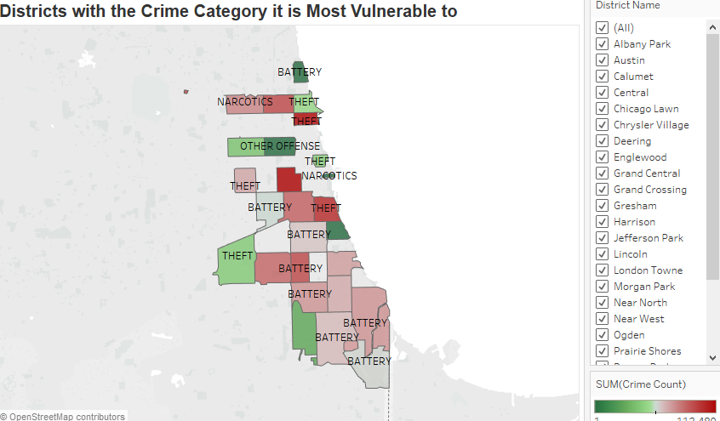

***Conclusion:*** *This analysis for the crime type each district is most vulnerable to. This will help the Police Department to concentrate on the measures to be taken to curb that crime type.*

**Query 4 : Year wise crime and arrest data**

create table query4 as

select a.year_crime,CrimeCount,ArrestCount from

(select year_crime,count(*) as CrimeCount

from crime_internal

group by year_crime)a

join

(select year_crime,count(*) as ArrestCount

from crime_internal

where arrest='TRUE'

group by year_crime)b

on a.year_crime=b.year_crime

order by year_crime;

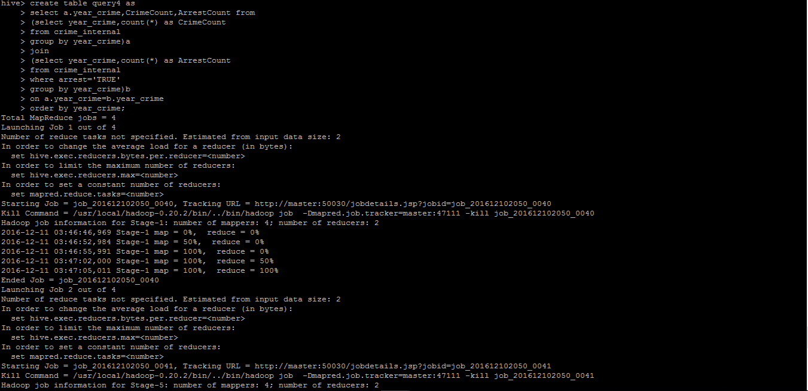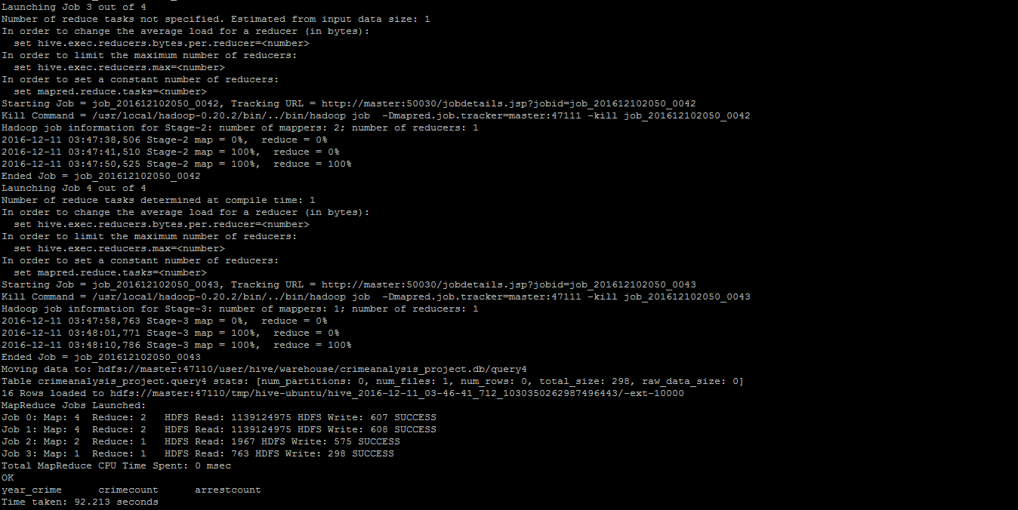

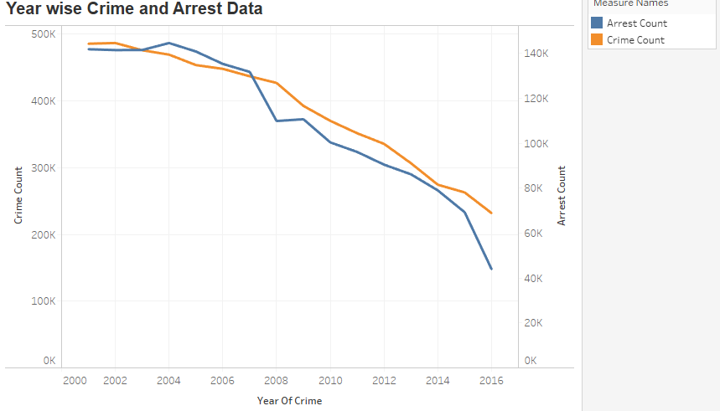

***Conclusion:*** *This analysis is crime and arrest rate on a yearly basis. This will we useful to Police Department to compare the crime and arrest rates on a yearly basis.*

**QUERY 5:** **Districts with the crime category having poor arrest rate**

drop table if exists query5;

create table query5 as

select a.district,y.district_name,y.zipcode,(ArrestCount/CrimeCount)*100 as TotalArrestPercentage,e.primary_type,min_percentage_district_crimetype as Primary_Type_Min_Arrest_Rate

from

(select district,count(*) as CrimeCount from crime_internal group by district)a

join

(select district,count(*) as ArrestCount from crime_internal where arrest='TRUE' group by district)b on a.district=b.district

join

(select district,min(percentage_district_crimetype) min_percentage_district_crimetype from

(

select a.district,a.primary_type,(arrrest_count_crimetype/total_count_crimetype)*100 percentage_district_crimetype

from

(select district,primary_type,count(*) as arrrest_count_crimetype

from crime_internal where arrest='TRUE'

group by district,primary_type)a

join

(select district,primary_type,count(*) as total_count_crimetype

from crime_internal group by district,primary_type)b on a.district=b.district and a.primary_type=b.primary_type)c group by district)d on a.district=d.district join

(

select a.district,a.primary_type,(arrrest_count_crimetype/total_count_crimetype)*100 percentage_district_crimetype

from

(select district,primary_type,count(*) as arrrest_count_crimetype

from crime_internal where arrest='TRUE'

group by district,primary_type)a

join

(select district,primary_type,count(*) as total_count_crimetype

from crime_internal group by district,primary_type)b on a.district=b.district and a.primary_type=b.primary_type)e on d.district=e.district and d.min_percentage_district_crimetype=e.percentage_district_crimetype

join districtdata_internal y on y.district=a.district;

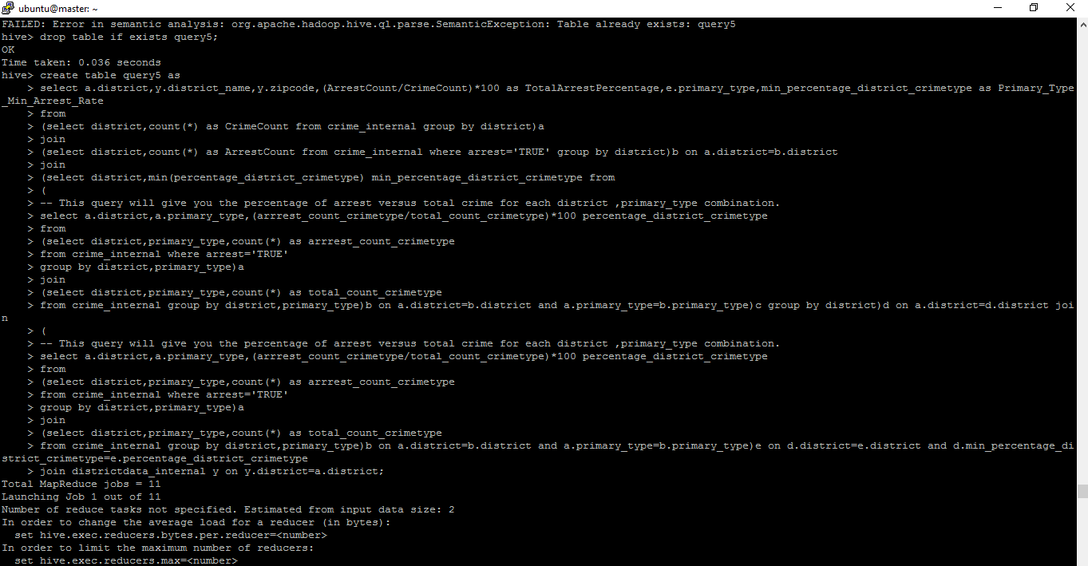

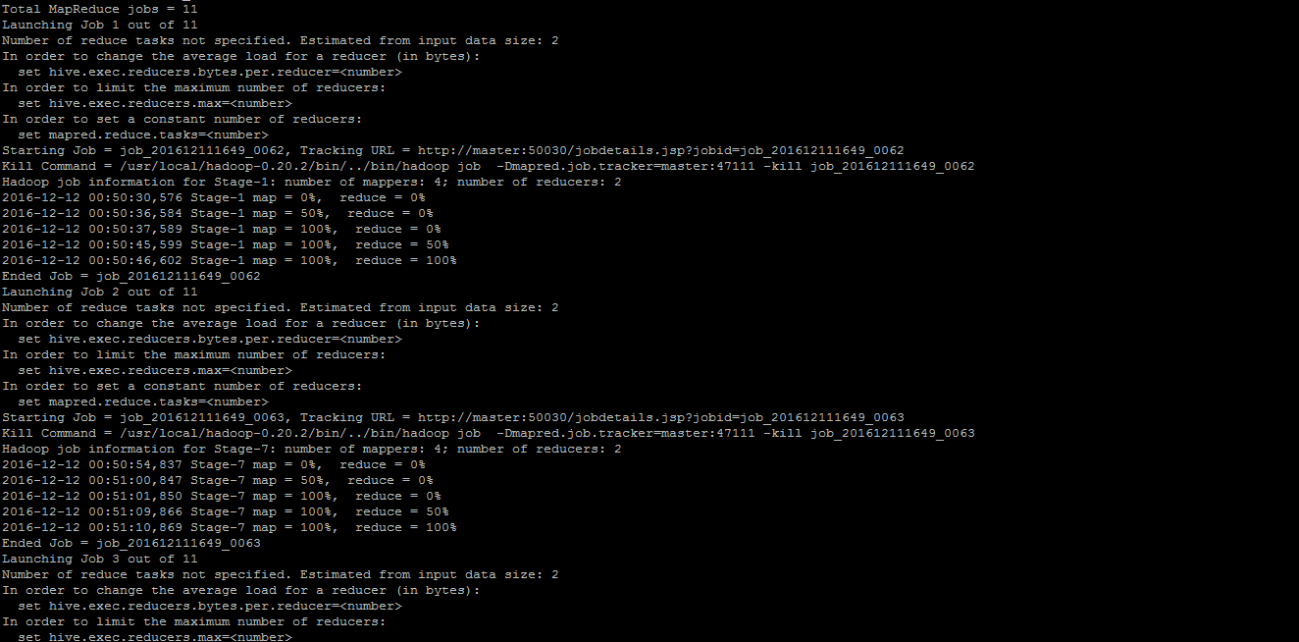

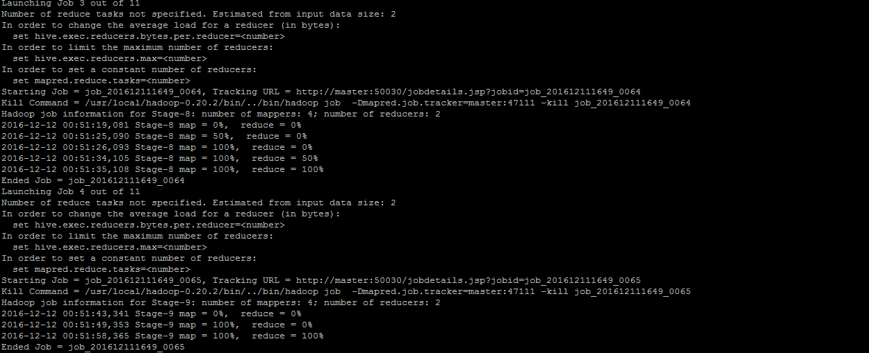

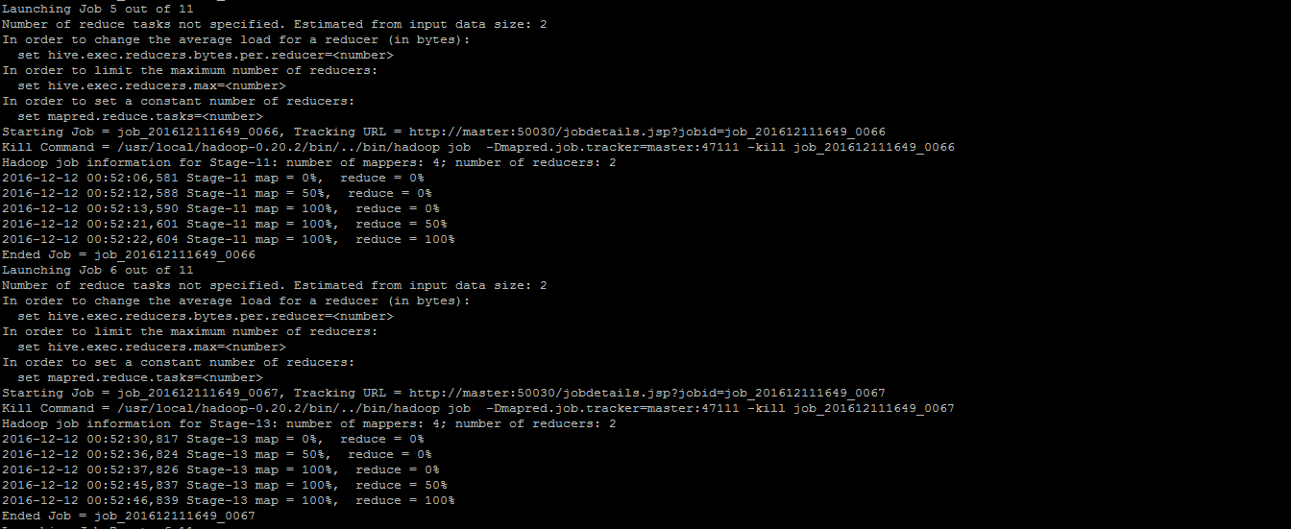

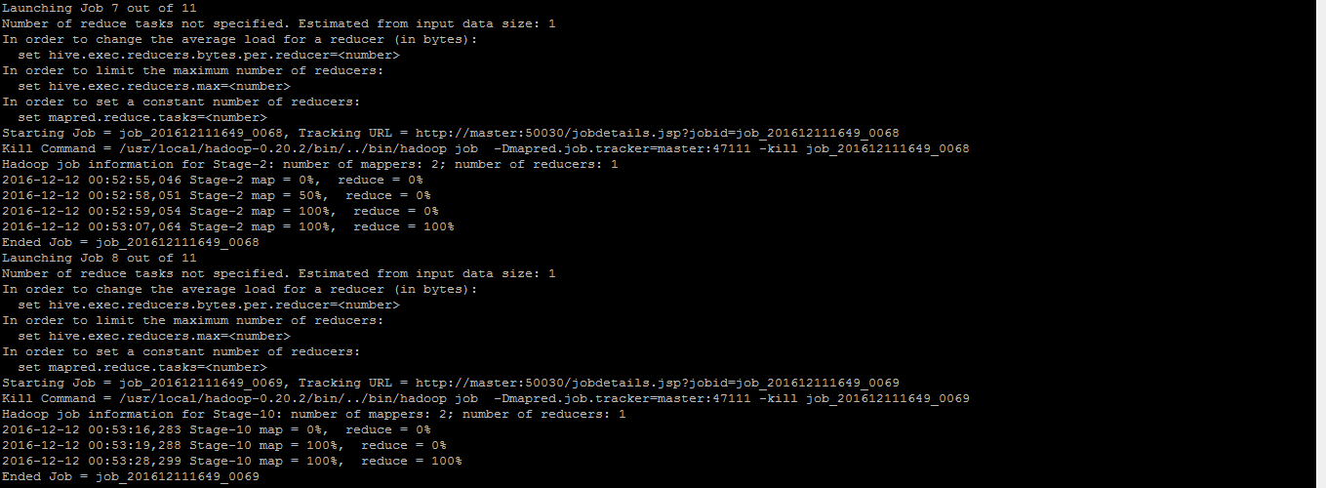

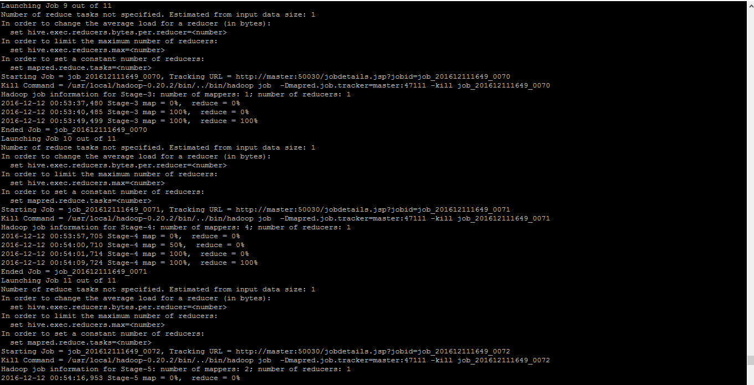

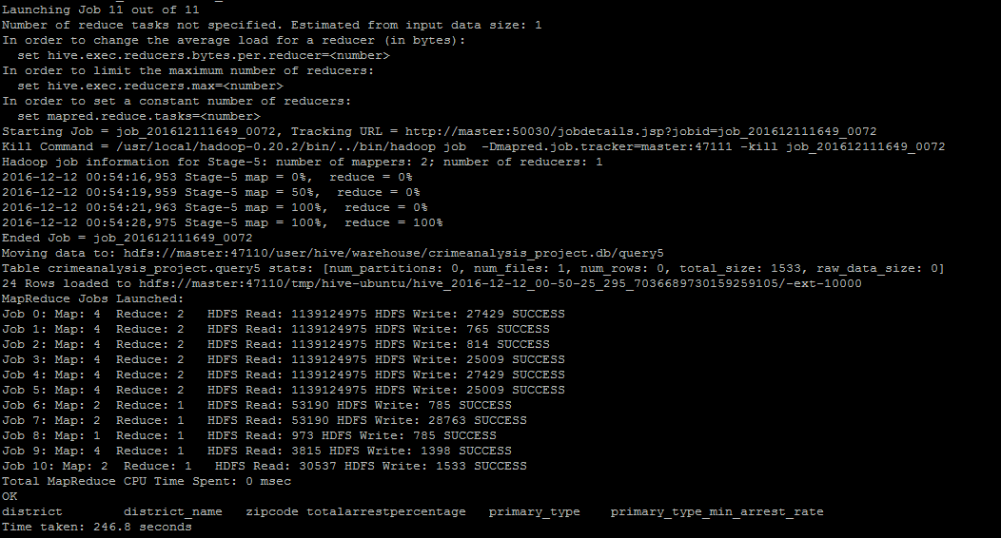

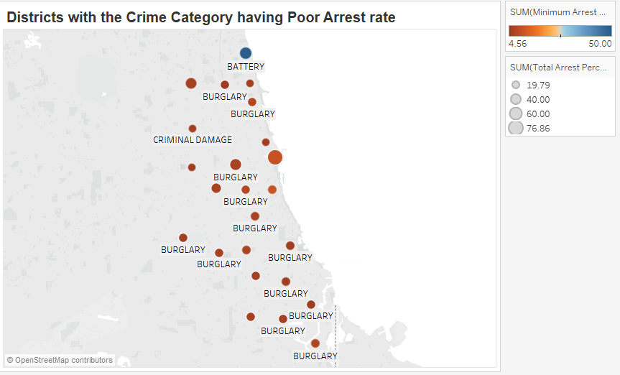

***Conclusion:*** *This analysis for which crime type the arrest rate is poor in each district. This will help the Police Department to analyse the system why the arrest rate is poor for that crime type and take appropriate measures on that.*

**Query6: Violent Crimes involving gun**

create table query6 as

select Year_crime, Count (case_number) as TotalCrimes,

SUM ( if ( (DESCRIPTION LIKE '%FIREARM%' OR

DESCRIPTION LIKE '%GUN%'), 1 , 0) ) AS TotalWithGuns,

SUM ( if (

(primary_type = 'ASSAULT' AND (DESCRIPTION LIKE '%FIREARM%' OR DESCRIPTION LIKE '%GUN%') AND (NOT DESCRIPTION LIKE '%SALE%' OR NOT DESCRIPTION LIKE '%POS%'))

OR

(primary_type = 'CRIM SEXUAL ASSAULT' AND (DESCRIPTION LIKE '%FIREARM%' OR DESCRIPTION LIKE '%GUN%') AND (NOT DESCRIPTION LIKE '%SALE%' OR NOT DESCRIPTION LIKE '%POS%'))

OR

(primary_type = 'OFFENSE INVOLVING CHILDREN' AND (DESCRIPTION LIKE '%FIREARM%' OR DESCRIPTION LIKE '%GUN%') AND (NOT DESCRIPTION LIKE '%SALE%' OR NOT DESCRIPTION LIKE '%POS%'))

OR

(primary_type = 'OTHER OFFENSE' AND (DESCRIPTION LIKE '%FIREARM%' OR DESCRIPTION LIKE '%GUN%') AND (NOT DESCRIPTION LIKE '%SALE%' OR NOT DESCRIPTION LIKE '%POS%'))

OR

(primary_type = 'RITUALISM' AND (DESCRIPTION LIKE '%FIREARM%' OR DESCRIPTION LIKE '%GUN%') AND (NOT DESCRIPTION LIKE '%SALE%' OR NOT DESCRIPTION LIKE '%POS%'))

OR

(primary_type = 'ROBBERY' AND (DESCRIPTION LIKE '%FIREARM%' OR DESCRIPTION LIKE '%GUN%') AND (NOT DESCRIPTION LIKE '%SALE%' OR NOT DESCRIPTION LIKE '%POS%'))

OR

(primary_type = 'WEAPSONS VIOLATION' AND (DESCRIPTION LIKE '%FIREARM%' OR DESCRIPTION LIKE '%GUN%') AND (NOT DESCRIPTION LIKE '%SALE%' OR NOT DESCRIPTION LIKE '%POS%'))

, 1 , 0)) AS TotalViolentWIthGuns

from crime_internal

group by Year_crime

order by Year_crime desc ;

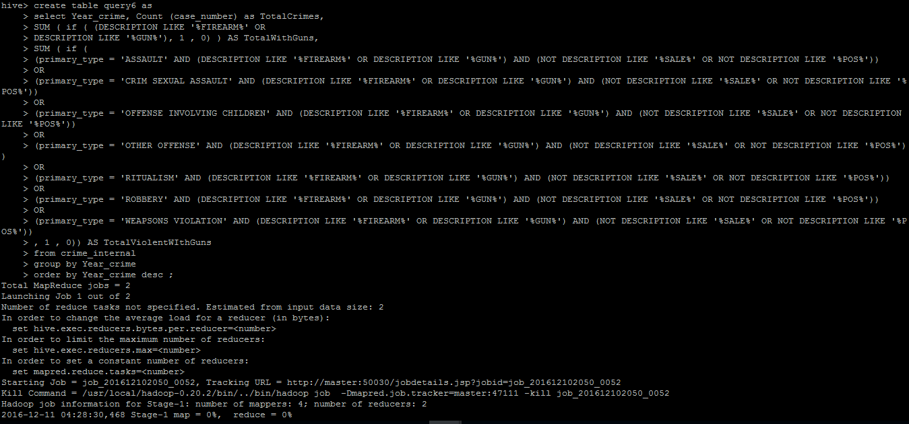

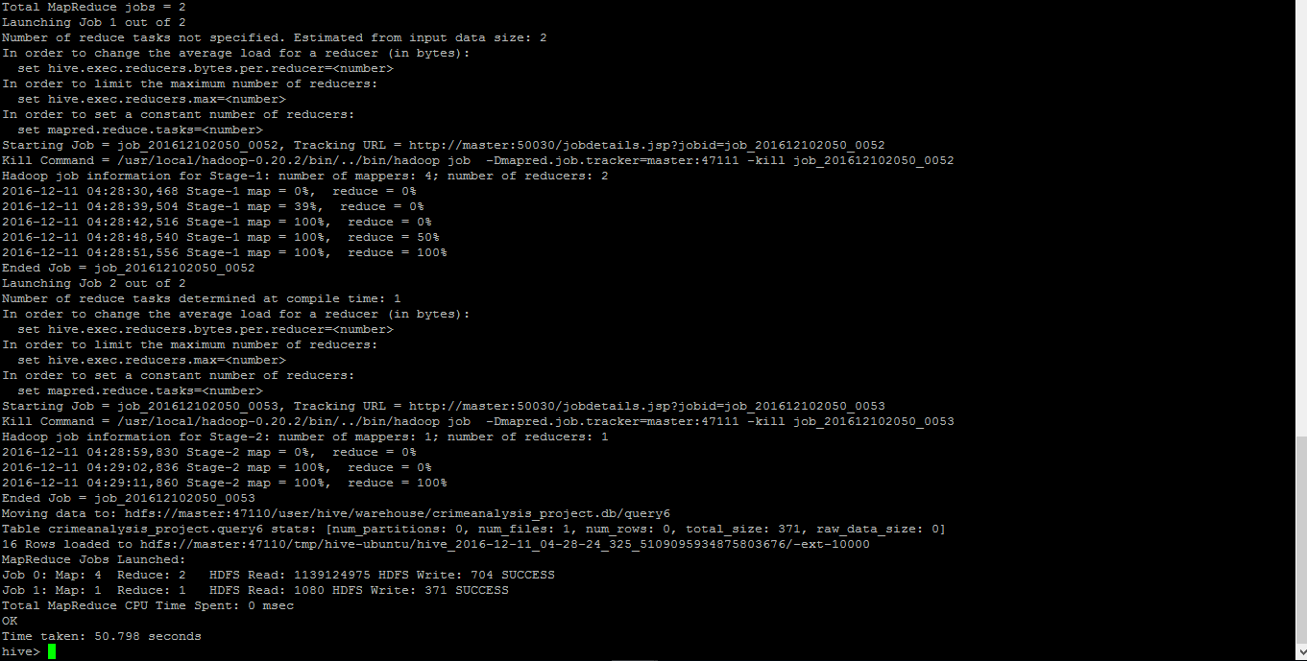

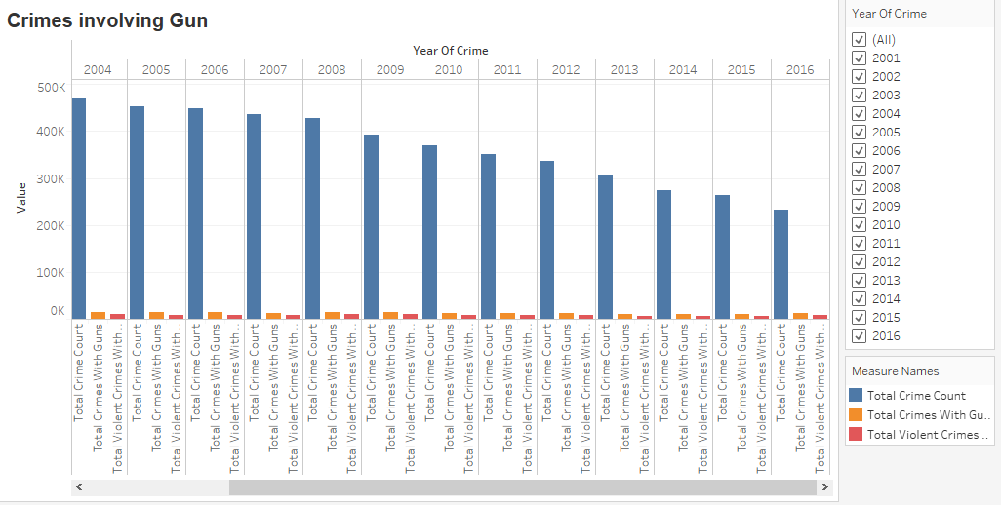

***Conclusion:*** *This analysis for the crimes involving gun and those which are violent among them on a yearly basis. This can be used by Police Department to keep an eye on crimes involving gun and which are violent among themand compare their occurrences each year.*

**Query7: Homicides criminal arrest rate by race and gender**

create table query_9 as

select a.race,a.gender,(Homicide_Criminal_Arrest_Count/Homicide_Count)*100 Homicide_Criminal_Arrest_Percentage from

(select race,gender,count(*) as Homicide_Count

from crime_homicide_queryData

group by race,gender) a

join

(select race,gender,count(*) as Homicide_Criminal_Arrest_Count

from crime_homicide_queryData

where arrest='TRUE'

group by race,gender) b

on a.race=b.race and a.gender=b.gender;

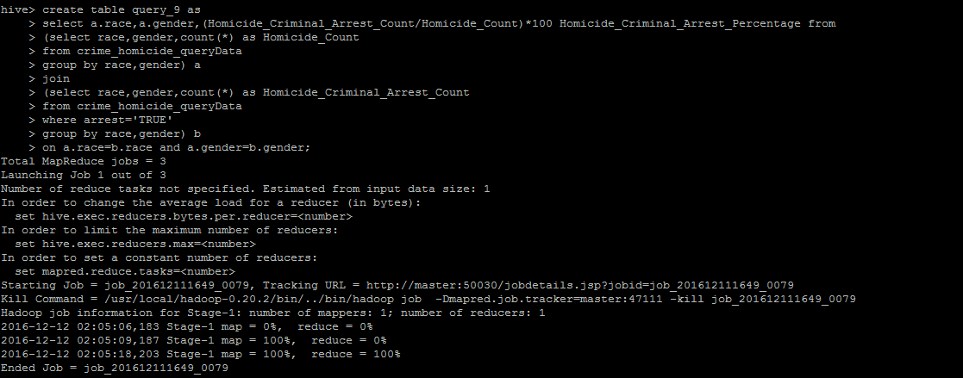

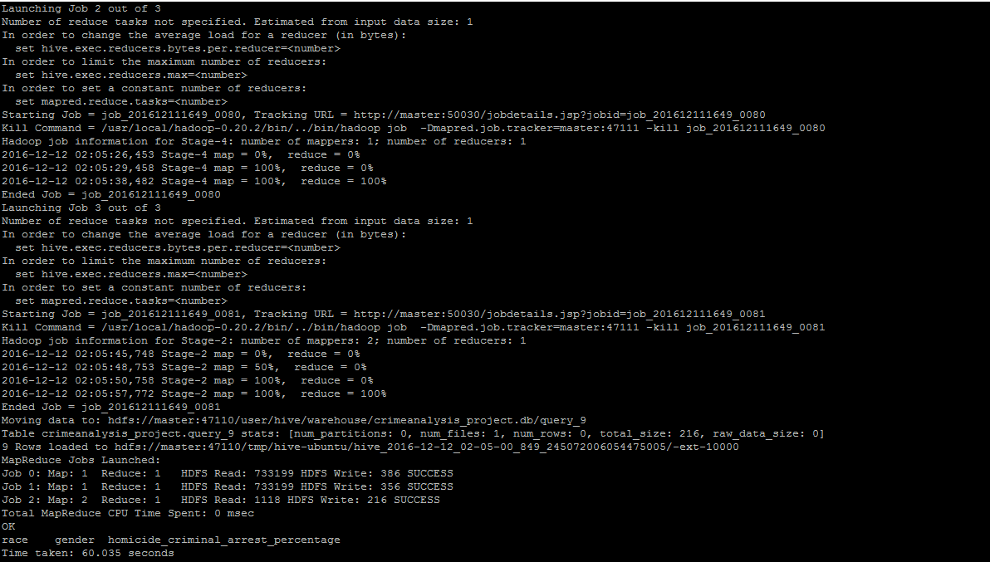

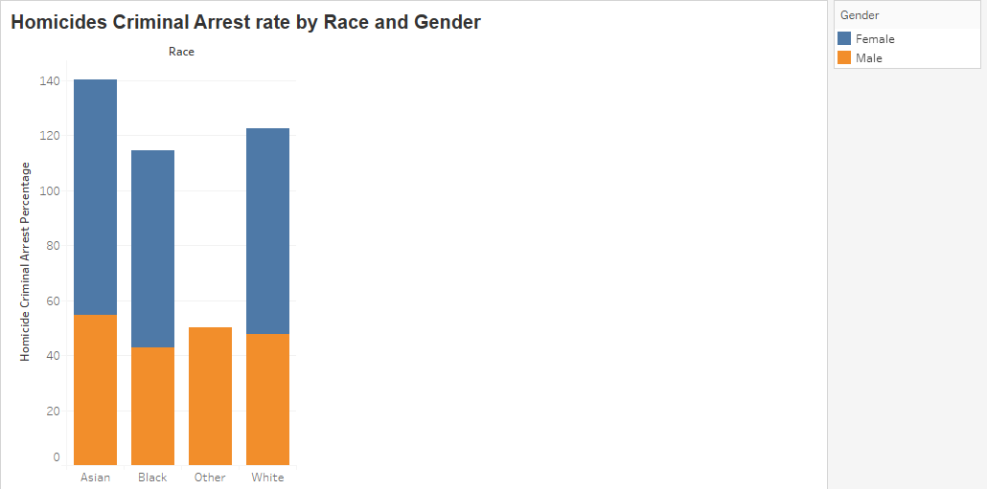

***Conclusion:*** *This analysis for analyzing the homicides by arrest rate of criminals based on victim’s race and gender. This will help the Police Department to emphasize on the investigation where the arrest rates are poor based on victim’s gender and ethnicity.*

**Query 10: Homicides by Geo Location**

create table query_10 as

select a.District_Name,a.latitude,a.longitude,count(*) Homicide_Count

from crime_homicide_queryData a

group by a.District_Name,a.latitude,a.longitude;

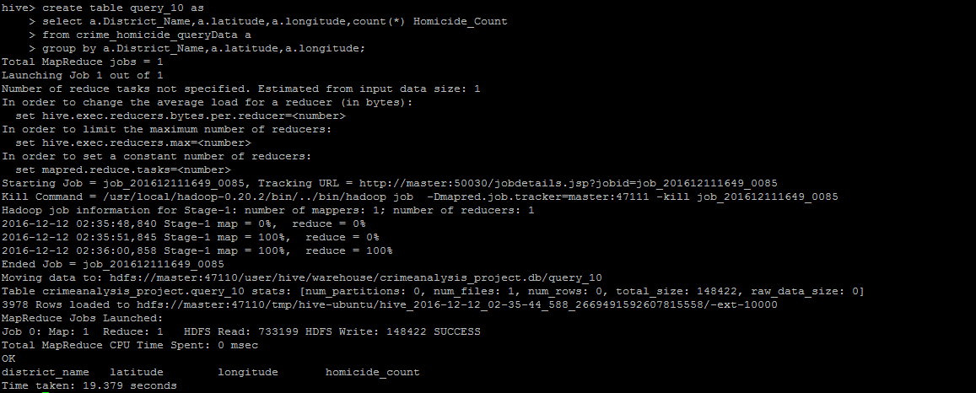

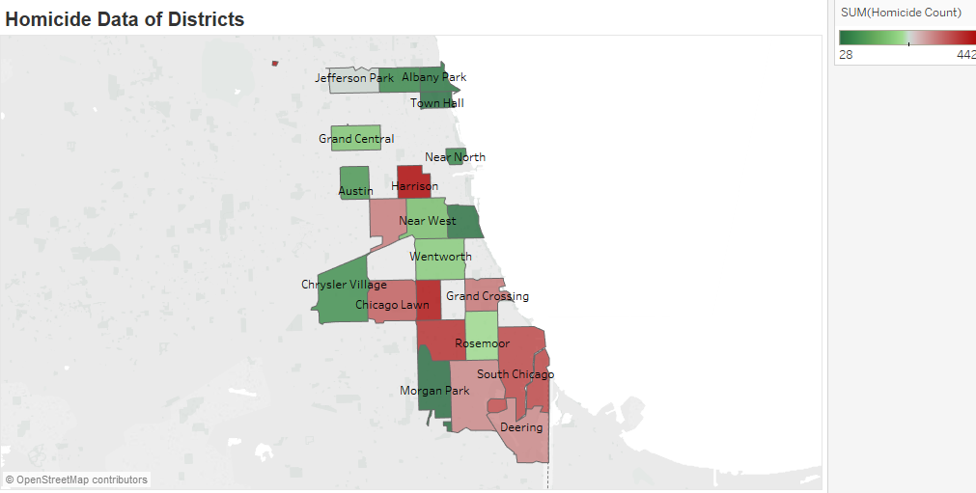

***Conclusion:*** *This analysis for analyzing the homicides in each district. This can be used by Police Department to concentrate on those districts where homicides are more and find the reasons behind them and take appropriate measures.*